JECRC
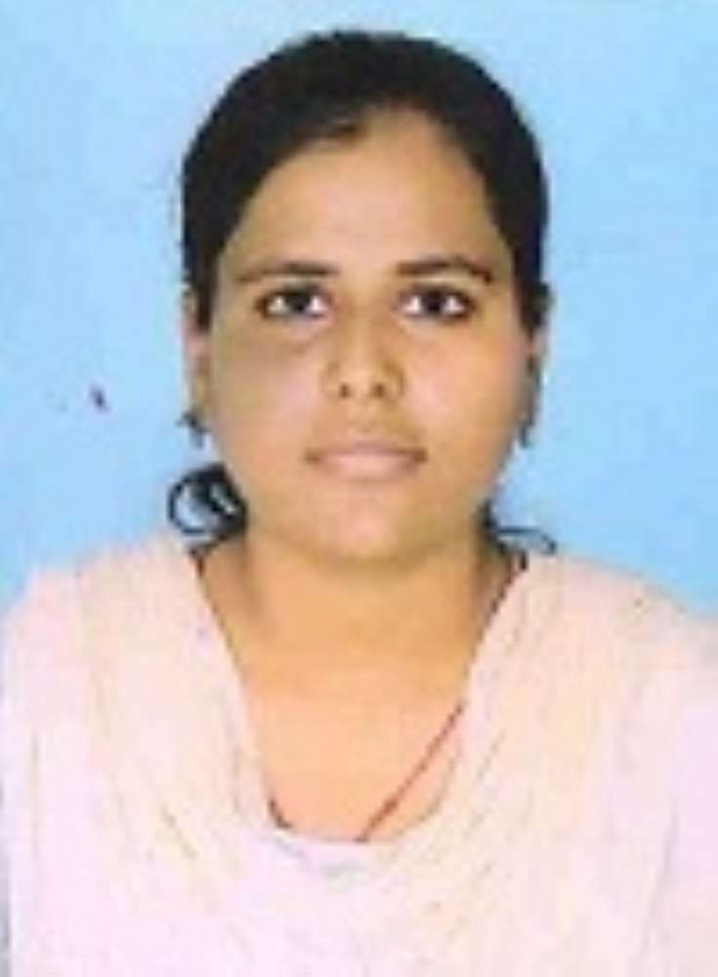
JAIPUR

INDIVIDUAL FACULTY DATA SHEET
Name of the faculty member | : | Neha Agrawal
Present Designation | : | Assistant professor
Email Id:
Contact Details:

I. Particulars of Educational Qualification: (only completed)

Category | Name of the Degree | Specialization | Year of Passing | Name of the College | Name of the University
UG | B.Tech | EEE | 2012 | LIETW | RTU,KOTA
PG | M.Tech | Power System | Perusing | SKIT | RTU,KOTA
Ph.D.

II. Academic Experience : 4 year

III. Industrial Experience : NIL

IV. Title of Ph.D. Thesis : NIL

V. Awards/Achievements : NIL

VI. Research/Specialization : DG Allocation in distribution system

VII. Course Taught : B.Tech (EE,ECE,1st Year)

VIII. Refereed International Journal Publication : Yes

IX. International Conference Proceeding : Yes

X. Books Written : No

XI. M.Tech Thesis Guide : Sarfaraz Nawaz

XII. PHD Thesis Guide : NIL

XIII. Professional Body Membership : NIL

